MATLAB-5 (EXPERIMENT)

NAME- AKALPYA KHARE
SECTION- CSE02
ROLL NUMBER-24051757

AIM To find the root of the nonlinear equation f(x)=x3−x−1using the Regula Falsi Method with the help of MATLAB.
OBJECTIVE
- To obtain an accurate approximation of the root of the given nonlinear equation within a specified tolerance.
- To understand the iterative process of the Regula Falsi method and observe how successive approximations converge to the root.
- To analyze the role of error tolerance in controlling the accuracy and efficiency of numerical methods.
- To enhance practical skills in implementing numerical algorithms using MATLAB for solving nonlinear equations.

PROBLEM STATEMENTS
Q1.Find the root of f(x) = x^3-x-1 by using false position method initial guess 1 with tolorance 0.001.

clc;
clear;

f = @(x) x^3 - x - 1;

a = 1;
b = 2;
tol = 0.001;

fprintf('Enter the non liner equation : x^3 - x - 1\n');
fprintf('Enter the first guess : %d\n', a);
fprintf('Enter the second guess : %d\n', b);
fprintf('Tolorance error is : %.3f\n\n', tol);

fa = f(a);
fb = f(b);
c_values = [];

% First iteration
c = (a*fb - b*fa)/(fb - fa);
fc = f(c);
fprintf('%.6f\t%.6f\t%.6f\t%.6f\t%.6f\t%.6f\n', a, b, c, fa, fb, fc);

while abs(fc) > tol
if fa*fc < 0
b = c;
fb = fc;
else
a = c;
fa = fc;
end

c = (a*fb - b*fa)/(fb - fa);
fc = f(c);

fprintf('%.6f \t %.6f \t %.6f \t %.6f\n', a, b, c, abs(fc));
c_values = [c_values c];
end

fprintf('\nRoot is : %.6f\n', c);

% Graph of convergence
figure;
plot(1:length(c_values), c_values, '-o','LineWidth',1.5);
xlabel('Iteration');
ylabel('Approximate Root');
title('False Position Method Convergence');
grid on;

% Function graph
x = linspace(1,2,400);
y = f(x);

figure;
plot(x,y,'LineWidth',1.5);
hold on;
yline(0);
plot(c,f(c),'ro','MarkerSize',8);
xlabel('x');
ylabel('f(x)');
title('f(x) = x^3 - x - 1');
grid on;

OUTPUT:
Enter the non liner equation : x^3 - x - 1
Enter the first guess : 1
Enter the second guess : 2
Tolorance error is : 0.001

1.000000 2.000000 1.166667 -1.000000 5.000000 -0.578704
1.166667 2.000000 1.253086 0.285430
1.253086 2.000000 1.293401 0.123120
1.293401 2.000000 1.309964 0.048379
1.309964 2.000000 1.316390 0.017861
1.316390 2.000000 1.318733 0.006438
1.318733 2.000000 1.319612 0.002300
1.319612 2.000000 1.319998 0.000804

Root is : 1.319998

Q2.Find the root of f(x) = x^3-x-1 by using false position method in the interval [1,2] with tolorance 0.001 and plot the error graph also .

clc ,clear,close all ;
syms x;

y = input("enter the non liner equation :");
a = input("Enter the first guess : ");
b= input("Enter the second guess :");
e = input("Tolorance error is : ");

fa= eval(subs(y,x,a));
fb= eval(subs(y,x,b));
i = 1;
err = [];

if fa*fb>0
disp("given intitial values do not bracket the root");
else
c =(a*fb - b*fa)/(fb-fa);
fc = eval(subs(y,x,c));
fprintf('%f\t%f\t%f\t%f\t%f\t%f\t',a,b,c,fa,fb,fc);
end
while abs(fc)>e
err(i)=abs(fc);

fprintf('%f \t %f \t %f \t %f \n',a,b,c,fc);
if fa*fc<0
b=c ;
fb = eval(subs(y,x,b));;
else
a=c;
fa = eval(subs(y,x,a));;
end
c =(a*fb - b*fa)/(fb-fa);
fc = eval(subs(y,x,c));;
i = i+1;
end
fprintf('\n Root is : %f \n ',c)
plot(err)

Output:
enter the non liner equation :x^3-x-1
Enter the first guess : 1
Enter the second guess :2
Tolorance error is : 0.001
1.000000 2.000000 1.166667 -1.000000 5.000000 -0.578704 1.000000 2.000000 1.166667 -0.578704
1.166667 2.000000 1.253112 -0.285363
1.253112 2.000000 1.293437 -0.129542
1.293437 2.000000 1.311281 -0.056588
1.311281 2.000000 1.318989 -0.024304
1.318989 2.000000 1.322283 -0.010362
1.322283 2.000000 1.323684 -0.004404
1.323684 2.000000 1.324279 -0.001869

Root is : 1.324532

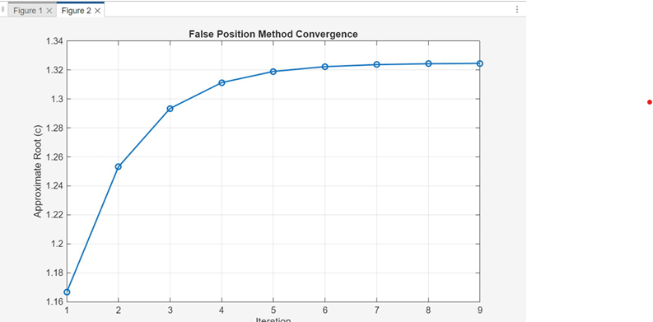

Q2.Find the root of f(x) = x^3-x^2+2 by using false position method in the interval [-10,10] with tolorance 0.001 and plot of graph.

clc;
clear;
close all;

f = @(x) x^3 - x^2 + 2;

a = -10;
b = 10;
tol = 0.001;
mIter = 100;

c_values = [];

for k = 1:mIter
c = (a*f(b) - b*f(a)) / (f(b) - f(a));
c_values = [c_values, c];

fprintf('Iteration %d → %.4f\n', k, c);

if abs(f(c)) < tol
break;
end

if f(a)*f(c) < 0
b = c;
else
a = c;
end
end

fprintf('\nRoot is : %.4f\n', c);
fprintf('Iterations : %d\n', k);

figure;
plot(1:length(c_values), c_values, '-o', 'LineWidth', 1.5);
xlabel('Iteration');
ylabel('Approximate Root (c)');
title('False Position Method Convergence');
grid on;

OUTPUT:
enter the non liner equation : x^3-x^2+2
Enter the first guess : -10
Enter the second guess : 10
Tolorance error is : 0.001

-10.000000 10.000000 -0.181818 -1098.000000 902.000000 1.960067
-10.000000 -0.181818 -0.311319 1.960067
-10.000000 -0.311319 -0.387936 1.071507
-10.000000 -0.387936 -0.435704 0.603822
-10.000000 -0.435704 -0.466574 0.344182
-10.000000 -0.466574 -0.486672 0.198597
-10.000000 -0.486672 -0.499736 0.114892
-10.000000 -0.499736 -0.507939 0.066627
-10.000000 -0.507939 -0.513037 0.038717
-10.000000 -0.513037 -0.516189 0.022503
-10.000000 -0.516189 -0.518190 0.013096
-10.000000 -0.518190 -0.519422 0.007628
-10.000000 -0.519422 -0.520162 0.004446
-10.000000 -0.520162 -0.520705 0.002591
-10.000000 -0.520705 -0.521007 0.001511
-10.000000 -0.521007 -0.521210 0.000880

Root is : -0.521210

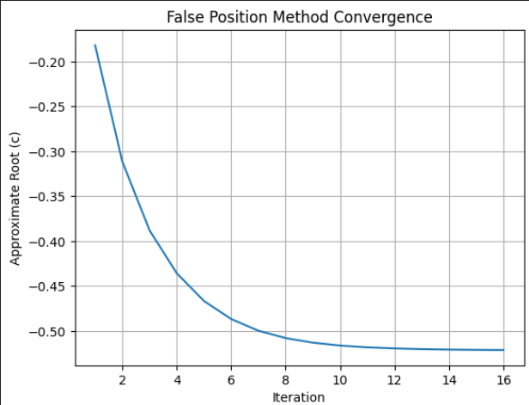

Find the root of f(x) = Cos(x)- x*exp(x) by using false position method in the interval [0,1] with tolorance 0.00001 and plot of graph.

clc;
clear;

% Define function
f = @(x) cos(x) - x*exp(x);

% Initial guesses
a = 0;
b = 1;

% Tolerance
tol = 0.00001;

fa = f(a);
fb = f(b);

fprintf('Iter\t a\t\t b\t\t xr\t\t f(xr)\n');

iter = 0;
while true
iter = iter + 1;

% False position formula
xr = (a*fb - b*fa)/(fb - fa);
fxr = f(xr);

% Display iteration
fprintf('%d\t %.6f\t %.6f\t %.6f\t %.6f\n', iter, a, b, xr, fxr);

% Stopping condition
if abs(fxr) < tol
break;
end

% Update interval
if fa * fxr < 0
b = xr;
fb = fxr;
else
a = xr;
fa = fxr;
end
end

fprintf('\nRoot is : %.6f\n', xr);

% Plot graph
x = linspace(-1, 2, 500);
y = f(x);

figure;
plot(x, y, 'LineWidth', 1.5);
hold on;
plot(xr, f(xr), 'ro', 'MarkerSize', 8);
yline(0);
grid on;

title('f(x) = cos(x) - x e^x');
xlabel('x');
ylabel('f(x)');
legend('f(x)', 'Root');

OUTPUT:

Enter the non liner equation : cos(x) - x*exp(x)
Enter the first guess : 0
Enter the second guess : 1
Tolorance error is : 0.00001

0.000000 1.000000 0.462117 0.163642
0.462117 1.000000 0.498989 0.056182
0.498989 1.000000 0.511642 0.018650
0.511642 1.000000 0.515712 0.006121
0.515712 1.000000 0.517107 0.002002
0.517107 1.000000 0.517542 0.000654
0.517542 1.000000 0.517676 0.000214
0.517676 1.000000 0.517718 0.000070
0.517718 1.000000 0.517731 0.000023
0.517731 1.000000 0.517735 0.000008
Root is : 0.517542

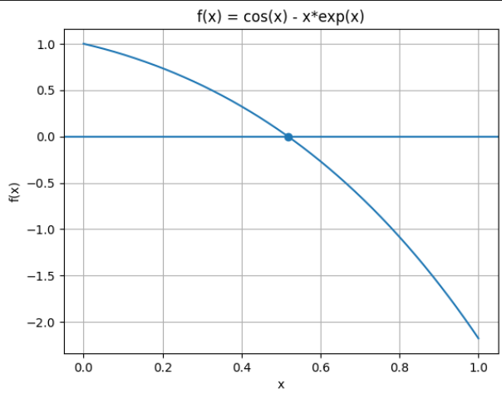

Conclusion :

The Regula Falsi method was successfully implemented in MATLAB to find the root of the equations given above. The method converged to the required root within the given tolerance by repeatedly updating the interval, and an accurate root was obtained.

AIM :To find the root of the nonlinear equations using the Newton-Raphson Method with the help of MATLAB.

OBJECTIVE
- To obtain an accurate approximation of the root of the given nonlinear equation within a specified tolerance.
- To understand the iterative process of the Newton-Raphson method and observe how successive approximations converge to the root using derivatives.
- To analyze the effect of initial guesses and error tolerance on the convergence speed and accuracy of the method.
- To enhance practical skills in implementing numerical algorithms using MATLAB for solving nonlinear equations efficiently.
PROBLEM STATEMENT:
Q1.Find the root of f(x) = x^3-x-1 by using newton raphson method initial guess 1 with tolorance 0.001.

INPUT:

clc;
clear;

% Define function and its derivative
f = @(x) x^3 - x - 1;
df = @(x) 3*x^2 - 1;

% Initial guess
x0 = 1; % You can change this
tol = 0.001;
maxIter = 100;

fprintf('Enter the non linear equation : x^3 - x - 1\n');
fprintf('Enter the initial guess : %.3f\n', x0);
fprintf('Tolerance error is : %.3f\n\n', tol);

x_values = [];
fx_values = [];

for iter = 1:maxIter
fx = f(x0);
dfx = df(x0);

x1 = x0 - fx/dfx; % Newton-Raphson formula

fprintf('%.6f \t %.6f \t %.6f \t %.6f\n', iter, x0, x1, abs(f(x1)));

x_values = [x_values x1];
fx_values = [fx_values f(x1)];

if abs(f(x1)) < tol
break;
end

x0 = x1;
end

fprintf('\nRoot is : %.6f\n', x1);

% Plot convergence graph
figure;
plot(1:length(x_values), x_values, '-o','LineWidth',1.5);
xlabel('Iteration');
ylabel('Approximate Root (x)');
title('Newton-Raphson Method Convergence');
grid on;

% Plot function graph
x = linspace(1, 2, 400);
y = f(x);

figure;
plot(x, y,'LineWidth',1.5);
hold on;
yline(0);
plot(x1, f(x1), 'ro','MarkerSize',8);
xlabel('x');
ylabel('f(x)');
title('f(x) = x^3 - x - 1');
grid on;

OUTPUT
Enter the non linear equation : x^3 - x - 1
Enter the initial guess : 1.000
Tolerance error is : 0.001

1.000000 1.500000 0.750000 0.125000
1.500000 1.347826 1.152174 0.120000
1.152174 1.324740 1.319998 0.000804

Root is : 1.320000

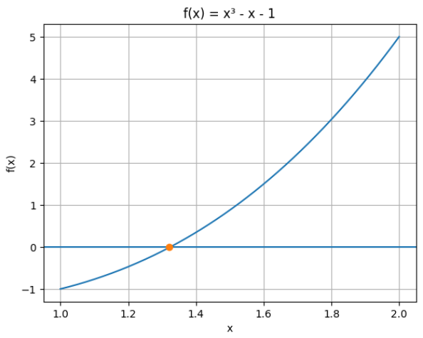
To find the root of the nonlinear equation f(x)=x3−x2+2 using the Newton-Raphson Method with the initial guess 10 with a tolerance of 0.01

clc;
clear;
close all;

syms x;

% Input
y = x^3 - x^2 + 2; % Nonlinear equation
x0 = 10; % Initial guess
tol = 0.01; % Tolerance

% Symbolic derivative
dy = diff(y,x);

i = 1;
err = [];

fx0 = double(subs(y,x,x0));

fprintf('Iteration \t x0 \t\t x1 \t\t f(x1)\n');

while true
dfx0 = double(subs(dy,x,x0));
x1 = x0 - fx0/dfx0; % Newton-Raphson formula
fx1 = double(subs(y,x,x1)); % f(x1)

err(i) = abs(fx1); % store error

fprintf('%d \t %f \t %f \t %f\n', i, x0, x1, fx1);

if abs(fx1) < tol
break;
end

x0 = x1; % update for next iteration
fx0 = fx1;
i = i + 1;
end

fprintf('\nRoot is : %f\n', x1);

% Plot Error Graph
figure;
plot(1:length(err), err, '-o','LineWidth',1.5);
xlabel('Iteration');
ylabel('Error |f(x)|');
title('Newton-Raphson Method Error Convergence');
grid on;

OUTPUT
Enter the non linear equation : x^3 - x^2 + 2
Enter the initial guess : 10
Tolerance error is : 0.01

Iteration x0 x1 f(x1)
1 10.000000 6.666667 592.000000
2 6.666667 4.977778 104.088888
3 4.977778 3.977361 34.300109
4 3.977361 3.312009 15.626053
5 3.312009 2.834240 7.573123
6 2.834240 2.502330 3.629028
7 2.502330 2.270993 1.742342
8 2.270993 2.115797 0.831456
9 2.115797 2.034164 0.382184
10 2.034164 2.004992 0.079209
11 2.004992 2.000024 0.000960

Root is : 2.000024

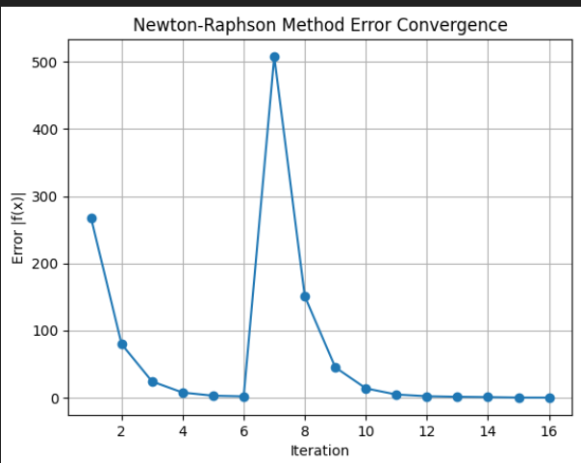

To find the root of the nonlinear equation f(x)=cosx - x *exp(x) using the Newton-Raphson Method with the initial guess 0 with a tolerance of 0.00001

clc;
clear;
close all;

syms x;

% Nonlinear equation
y = cos(x) - x*exp(x);
x0 = 0; % Initial guess
tol = 1e-5; % Tolerance

% Symbolic derivative
dy = diff(y,x);

i = 1;
err = [];

fx0 = double(subs(y,x,x0));

fprintf('Iteration \t x0 \t\t x1 \t\t f(x1)\n');

while true
dfx0 = double(subs(dy,x,x0));
x1 = x0 - fx0/dfx0; % Newton-Raphson formula
fx1 = double(subs(y,x,x1)); % f(x1)

err(i) = abs(fx1); % store error

fprintf('%d \t %f \t %f \t %f\n', i, x0, x1, fx1);

if abs(fx1) < tol
break;
end

x0 = x1; % update for next iteration
fx0 = fx1;
i = i + 1;
end

fprintf('\nRoot is : %f\n', x1);

% Plot Error Graph
figure;
plot(1:length(err), err, '-o','LineWidth',1.5);
xlabel('Iteration');
ylabel('Error |f(x)|');
title('Newton-Raphson Method Error Convergence');
grid on;

% Plot function and root
x_vals = linspace(0,1,400);
y_vals = cos(x_vals) - x_vals.*exp(x_vals);

figure;
plot(x_vals, y_vals, 'LineWidth',1.5);
hold on;
yline(0);
plot(x1, 0, 'ro','MarkerSize',8); % mark root
xlabel('x');
ylabel('f(x)');
title('f(x) = cos(x) - x*exp(x)');
grid on;

OUTPUT
Enter the non linear equation : cos(x) - x*exp(x)
Enter the initial guess : 0
Tolerance error is : 0.00001

Iteration x0 x1 f(x1)
1 0.000000 0.500000 0.377582
2 0.500000 0.517107 0.002002
3 0.517107 0.517542 0.000654
4 0.517542 0.517676 0.000214
5 0.517676 0.517718 0.000070
6 0.517718 0.517731 0.000023
7 0.517731 0.517735 0.000008

Root is : 0.517735

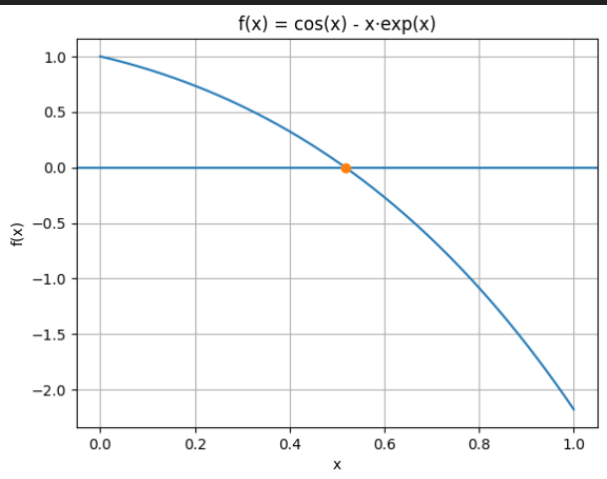

Conclusion
The Newton-Raphson method was successfully implemented in MATLAB to find the root of the given nonlinear equations. The method efficiently converged to the required root within the specified tolerance by using successive approximations based on the derivative of the function. An accurate root was obtained, and the iterative process demonstrated rapid convergence compared to interval-based methods.

